DIS-MASK-AFR-KUBA-CONGO

# LARGEOLDER USED KUBA M'BOOM MASK METAL - BEADS- CLOTH

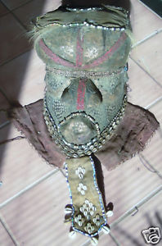

Ba KUBA   
M"BOOM   
CONGO,   
WOOD : 13 " TALL  x   13 " DEEP  x  12" ACROSS  
 EARLY TO MID 20th CENTURY

The Kuba kingdom was founded in the 16th century by the Bushoong people.   
Today they number about 70 000 and are still ruled by a king – the 21st to have held the title. Tribal history relates that the Kuba migrated from the far North to their current location along the Sankuru River .  Upon arrival the Kuba found the Twa tribe already resident along the Sankuru River.  The Twa were culturally absorbed into the more powerful Kuba tribe but remnants of the Twa cultural characteristics still remain.  The Kuba kingdom reached its height in the mid-19th century and contact with Europeans for the purpose of slave trading occurred in 1884.  However, due to their relative isolation the Kuba were not as heavily affected by the slave traders as other tribes.  Eventually the Nsapo tribe invaded the Kuba kingdom and the Kingdom was largely dispersed and broken up.

*This superb mask is one of the three "most significant" masks of the BaKuba, this mask represents the brother of Woot, the 'first ancestor', rather like Adam. The brothers vied for the affection of their sister, who later married Woot. This mask has a bulbous forehead. Sometimes copper ornaments the forehead. Raffia headress and beard are embroidered with cowries, and beads are sometimes found on nose, forehead, lips, and back of headdress.  
 The raffia is hand-woven.There is brass  on the face and the beads are glass.*

 SHELLS, ANIMAL SKINS, FUR, WOOD , BEADS, CLOTH, COPPER. *THE CONDITION IS EXCELLENT. THE INSIDE HAS GOOD WEAR*

VALUE $ 750.00+